Document For

**Using SQL Developer in Visual Studio Code.**

`

**Document Revision History**

|  |  |  |  |  |  |
| --- | --- | --- | --- | --- | --- |
| **Date** | **Version No.** | **Author** | **Reviewer** | **Approver** | **Change Summary** |
| 19-Nov-24 | 1.0 | Narendar V | Navu K |  |  |
|  |  |  |  |  |  |

Contents

1 INSTALLATION STEPS 4

2 HOW TO USE IT? 8

# INSTALLATION STEPS

**Step 1: Download Visual Studio Code (VS Code)**

* Download the Visual Studio Code setup for Windows from the official website:

|  |
| --- |
| [Download Visual Studio Code - Mac, Linux, Windows](https://code.visualstudio.com/download) |

**Step 2: Run the Setup**

* Open the downloaded setup file.
* Select **"I accept the agreement"** and click Next.

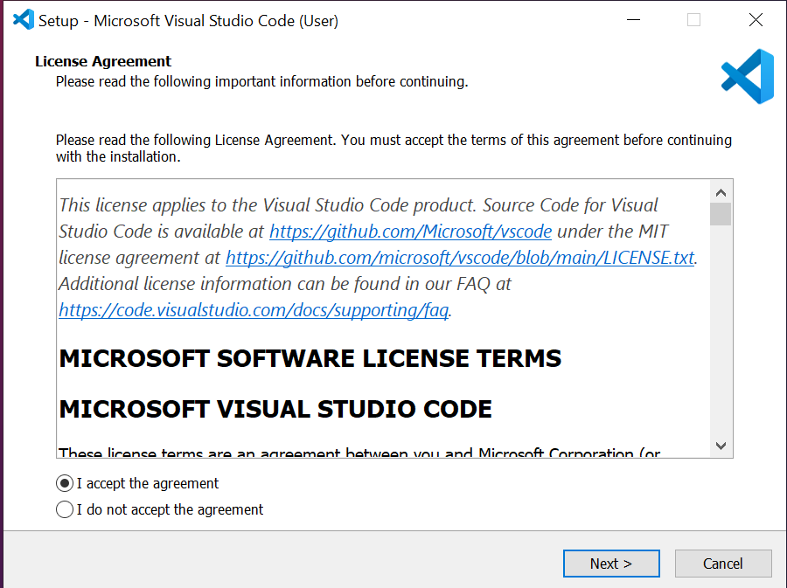

**Step 3: Choose Setup Options**

* Check the option **"Create a desktop icon"** and click **Next**.

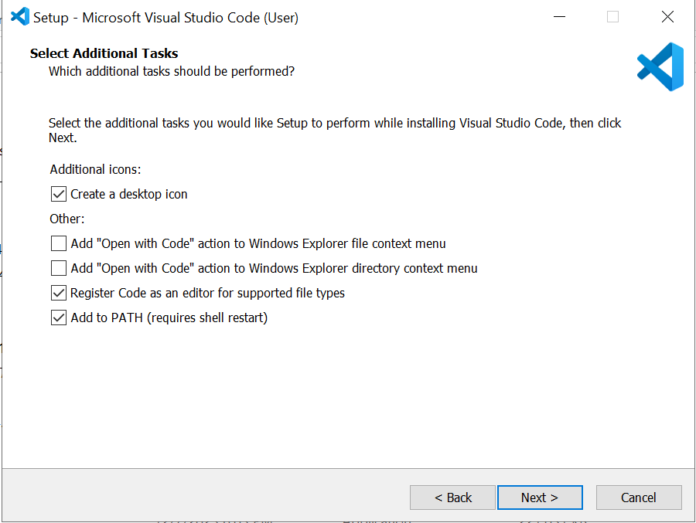

* Click **Install** to begin the installation process.

**Set Up Oracle SQL Developer in VS Code**

* Open Visual Studio Code (VS Code).
* **Go to the Extensions Menu** on the left side toolbar.

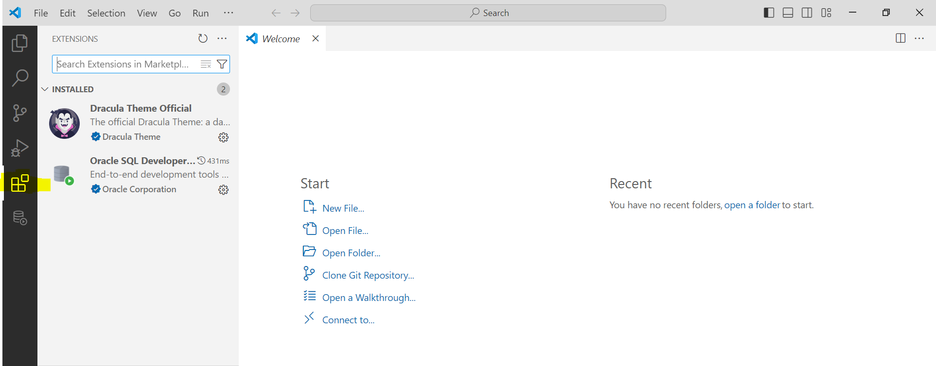

* **Search for "Oracle SQL Developer"**, then click on it and click **Install**.

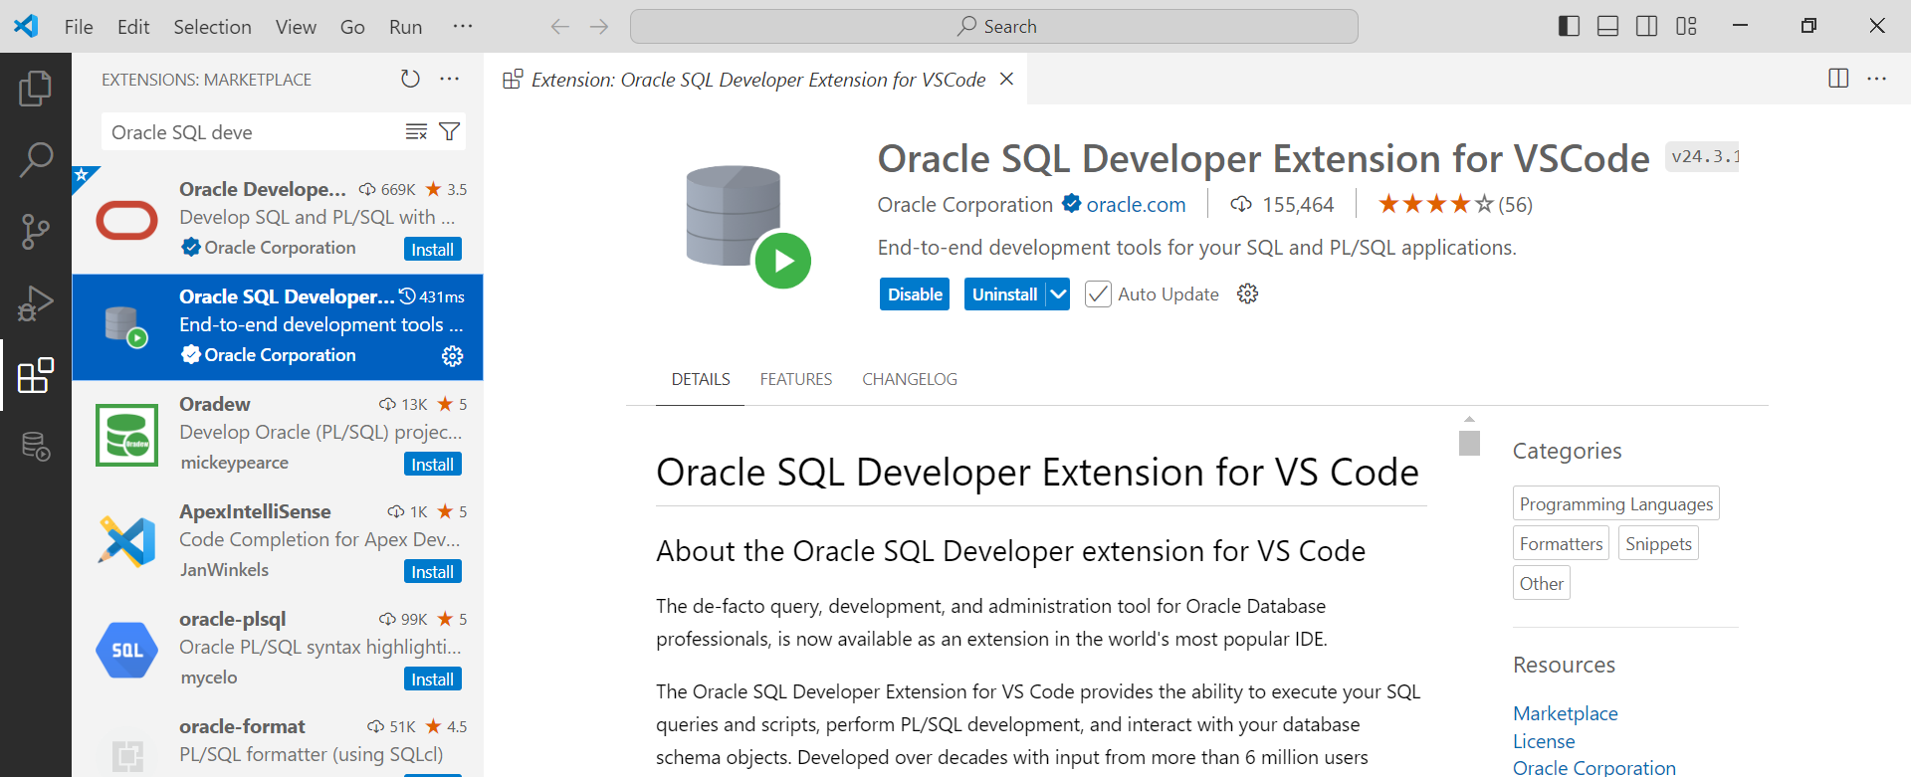

* After installation, the **Database symbol** will appear and be enabled on the toolbar.

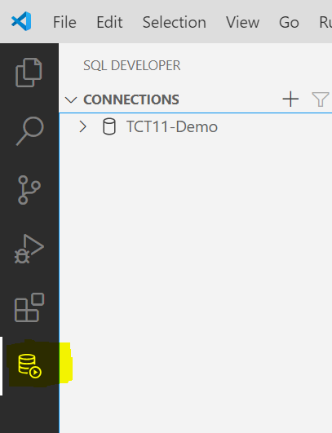

* Go to the extension menu on toolbar and click settings symbol on Oracle SQL Developer.

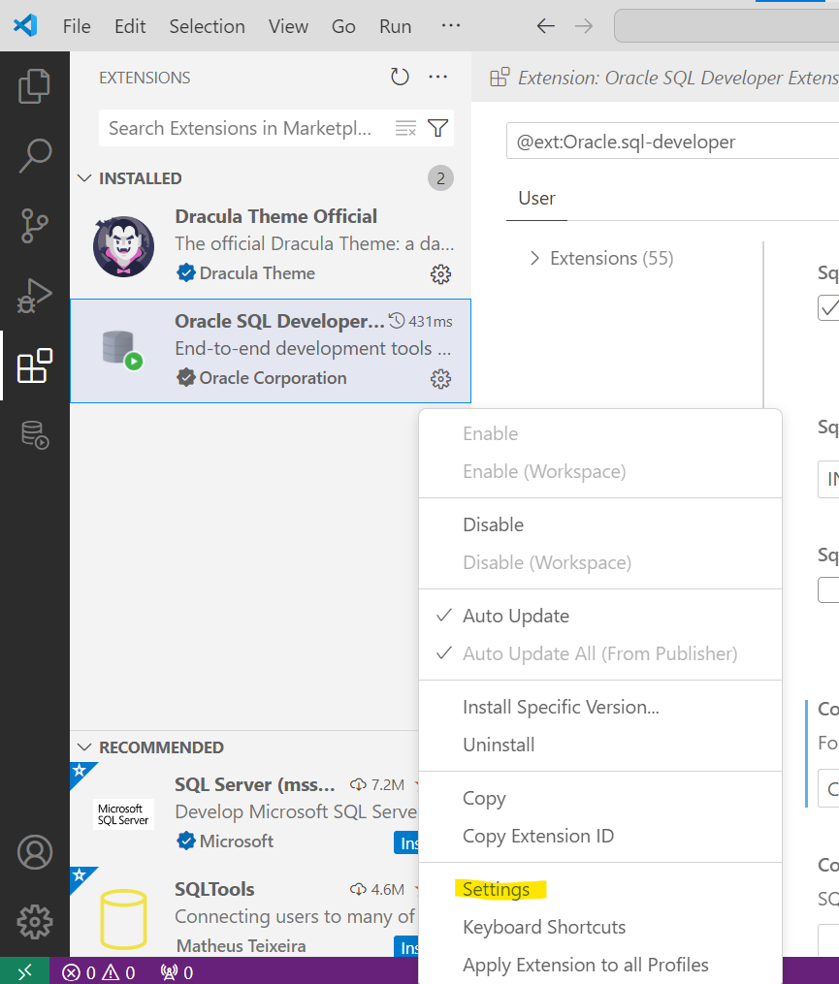

* Add the path to the tnsnames.ora file.

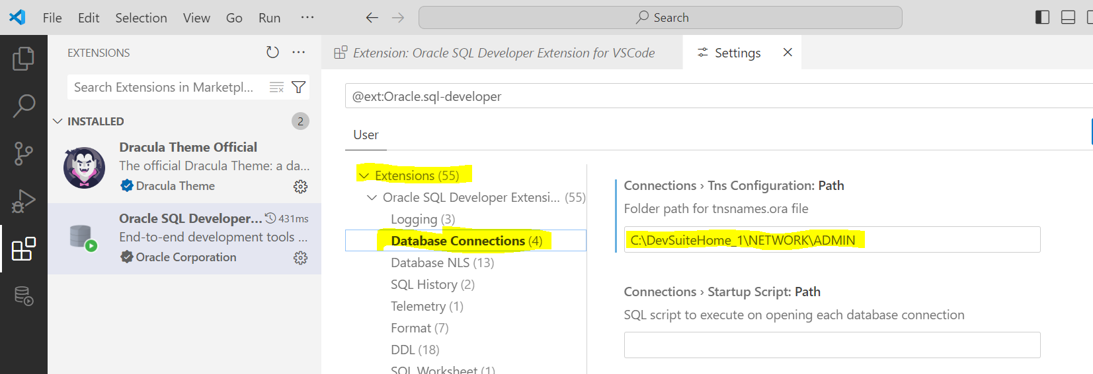

* Once the above steps are completed, go to the **SQL Developer** icon in the toolbar.
* Add a database connection.

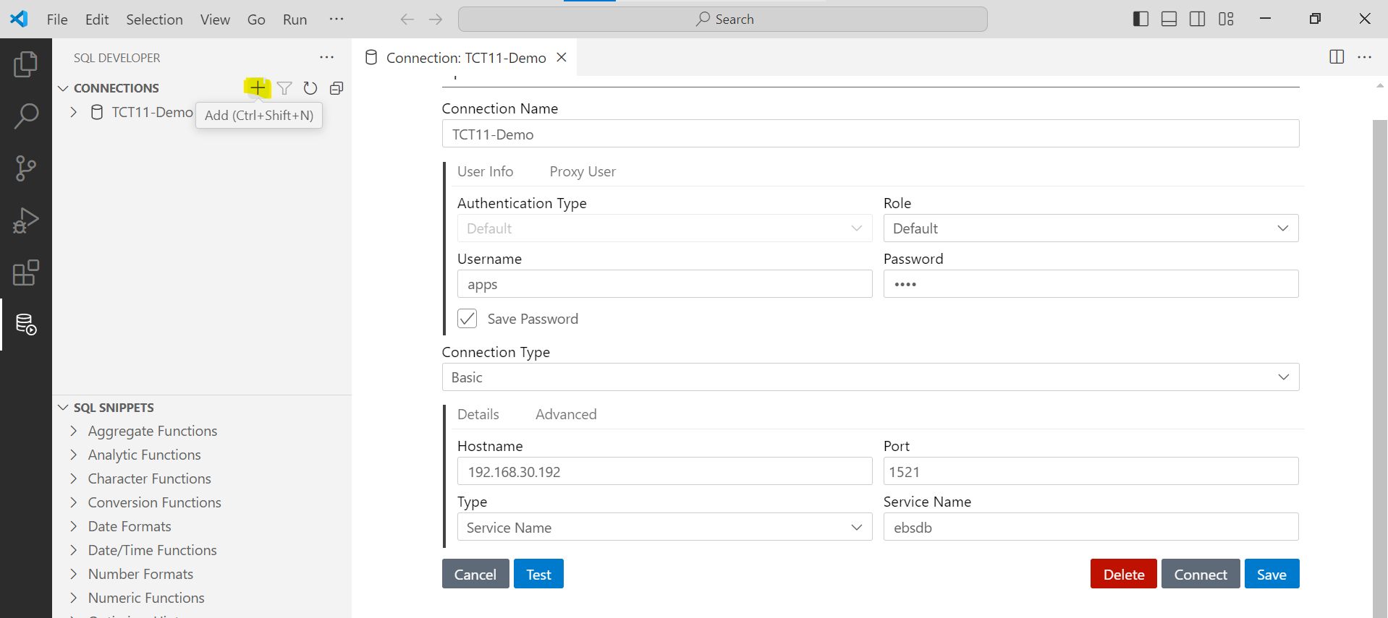

* **Click "Test" to verify the connection** and then click **Connect**.
* SQL Developer is now ready to use within VS Code.

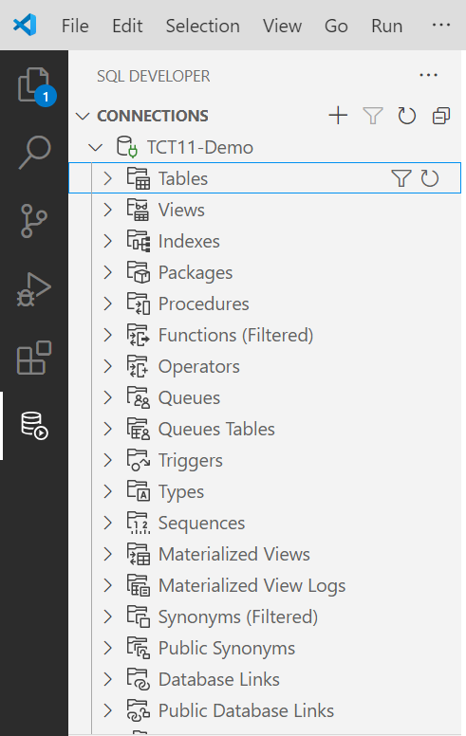

# HOW TO USE IT?

**2.1 Using the SQL Worksheet in VS Code**

* Each connection has a **Worksheet** icon.

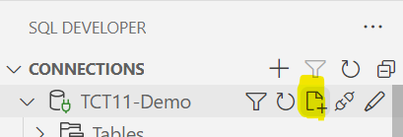

* Click the **Worksheet** icon to start developing queries.

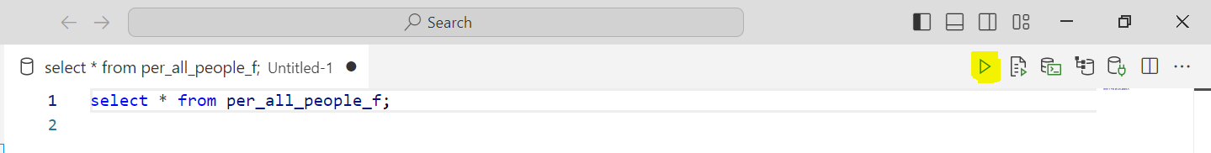

* Action Buttons Available in the SQL Worksheet:  
    
     
  + **Run Statement:** Execute a single SQL statement.
  + **Run Script:** Run an entire script with multiple statements.
  + **Run SQLcl:** Execute commands in the terminal using SQLcl.
  + **Explain Plan:** Generate an execution plan for the query.
  + **Attach/Detach Connection:** Connect or disconnect the worksheet from a database connection.

**2.2 SQL Snippet**

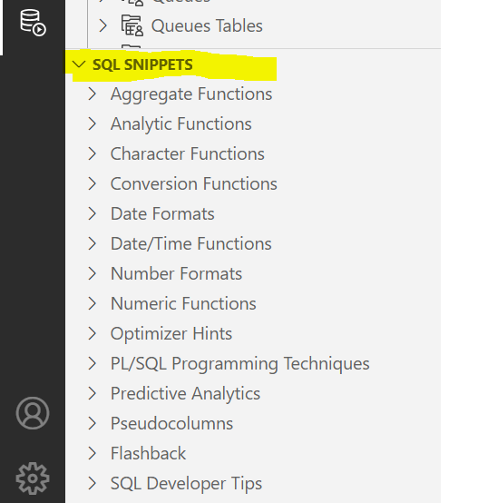

* This is an additional feature supported by VS Code: **"SQL Snippets."**
* It provides shortcut options for SQL functions, optimizer hints, date formats, conversions, and PL/SQL techniques.
* These snippets can be easily used by simply dragging and dropping.

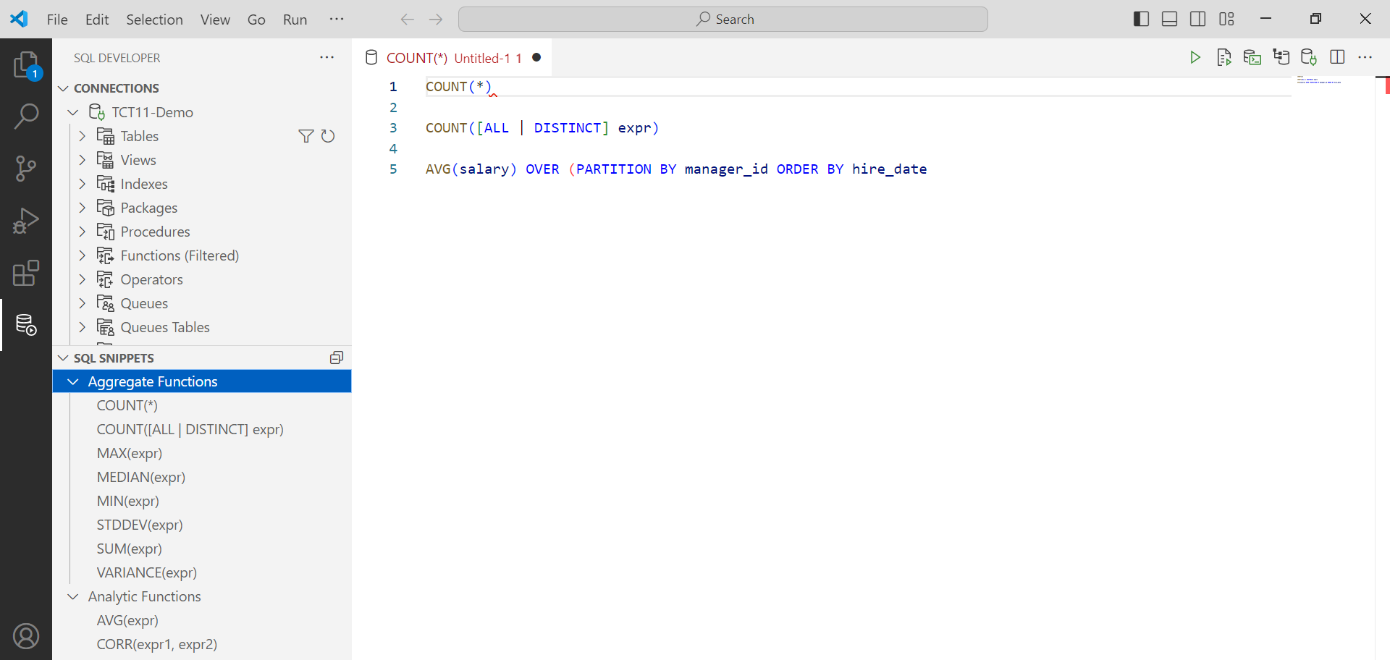

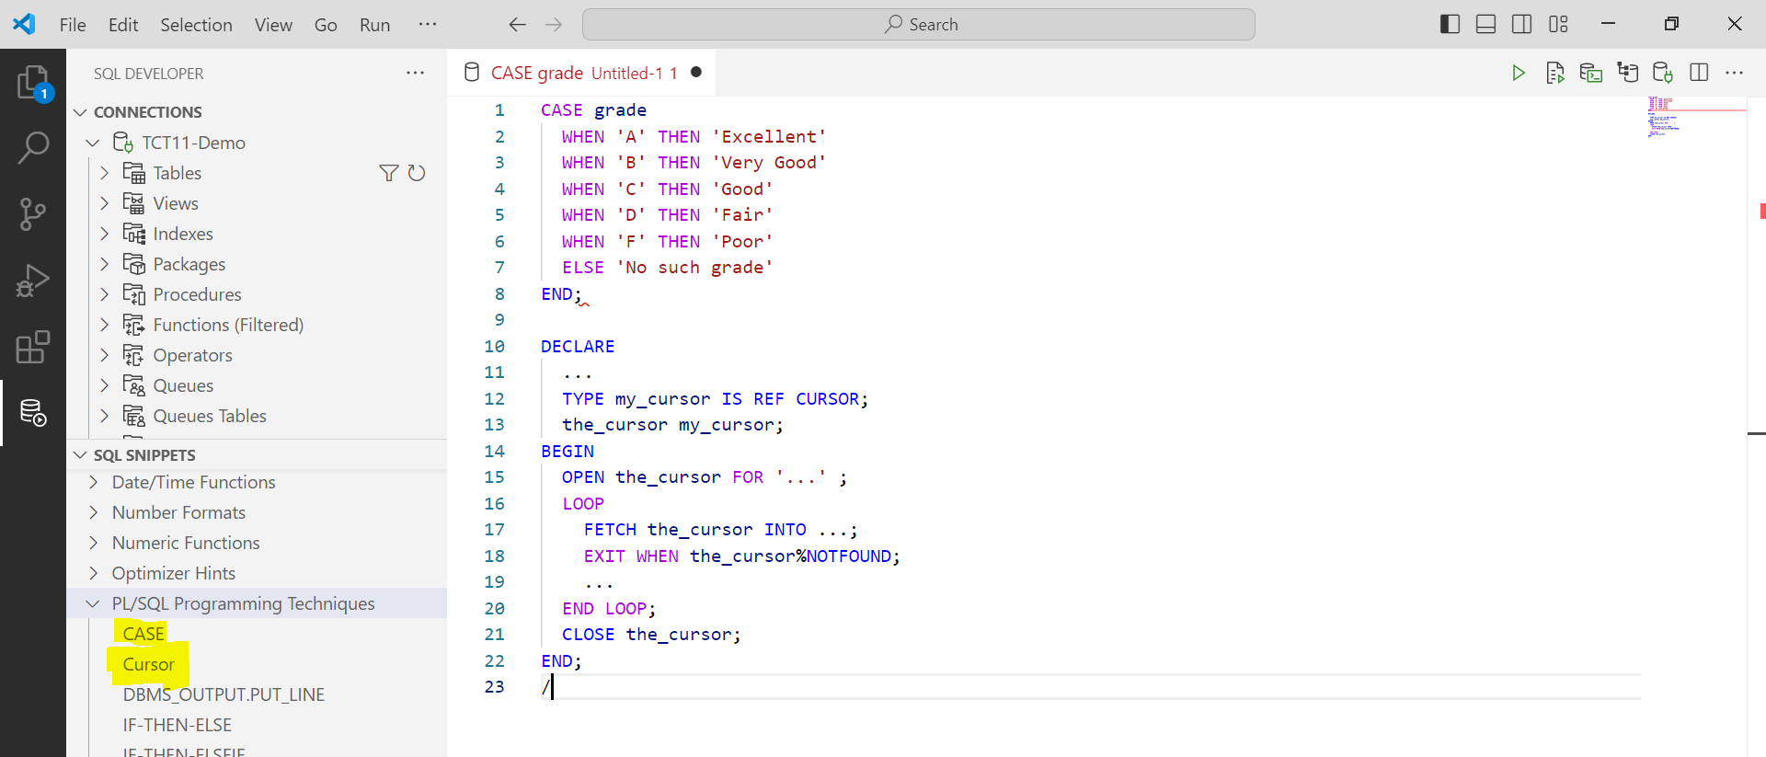

**2.3 Changing the Editor Theme in VS Code**

* To change color theme.
  + Open the editor or worksheet.
  + Right-click and select **"Command Palette."**
  + Type **"Color Theme"** and select **"Preferences: Color Theme"** from the options.

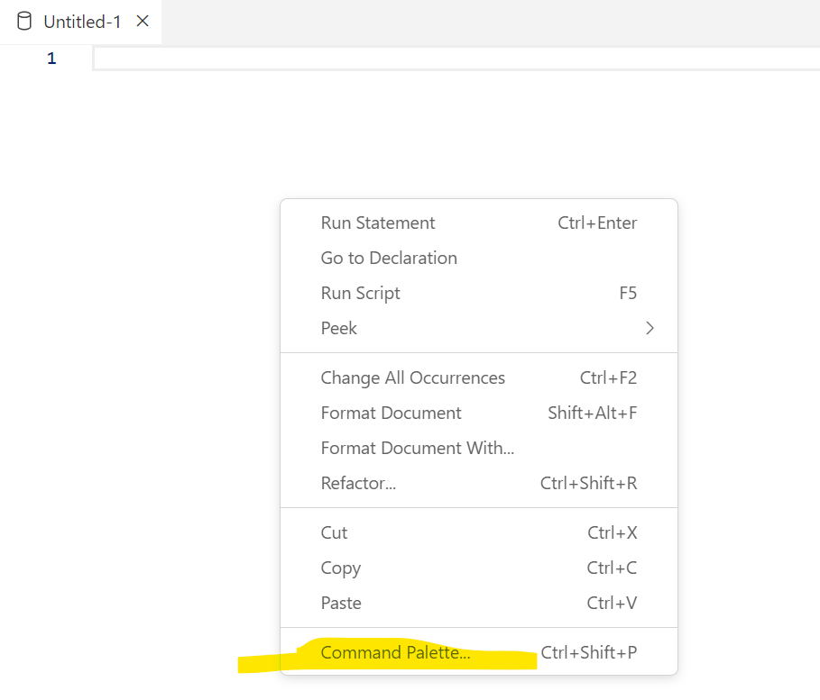



* Choose any theme, and the editor's color scheme will be updated immediately.

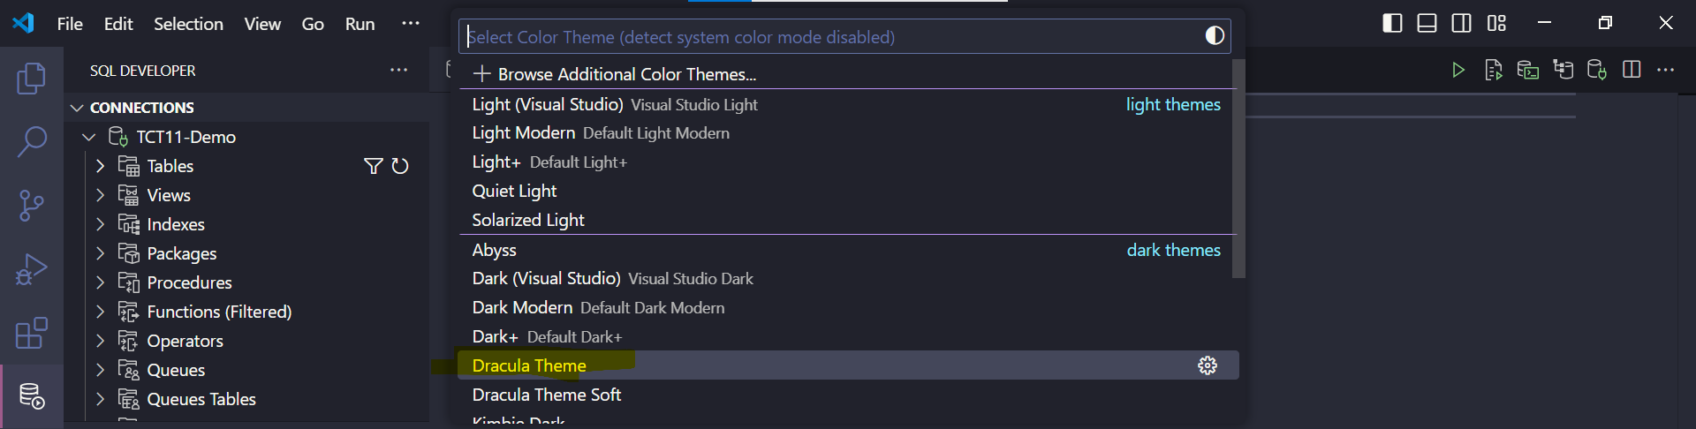

**2.4 Drag-and-Drop SQL Script Generation in VS Code**

* In VS Code, there is a feature where you can simply select, drag, and drop columns or tables, which will automatically write statements such as SELECT, INSERT, DELETE, UPDATE, and JOIN for the selected tables.
* Locate the objects under **Connections** and select the required object or columns.
* Drag them to the worksheet, and a window will appear, allowing you to choose the desired operation.

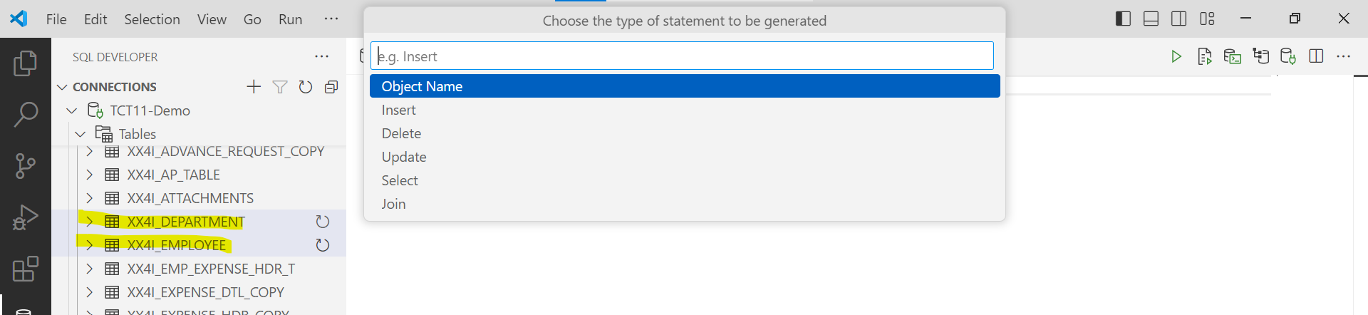

* Select the operation you need.
* The resulting output will be displayed as shown below.

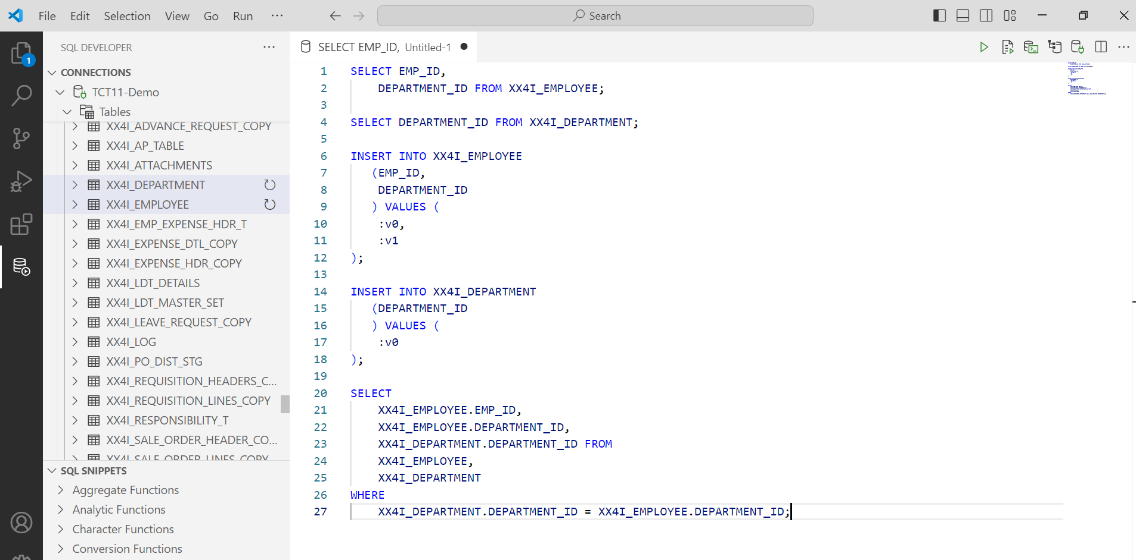

**NOTE:** Use the Drag-and-Drop Generate Script feature in VS Code to create a JOIN between two tables. Ensure there is a foreign key constraint (relationship) between them.

**2.5 Generate Anonymous Block for PL/SQL Scripts in VS Code**

* Locate the object under the connections and select the required object.
* On the action button, click run.
* A new tab will open, as shown below.

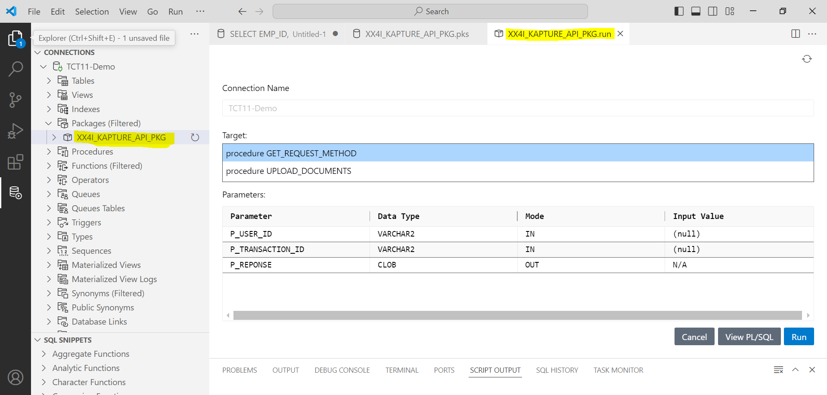

* In the parameter block, there is an input field where you can directly enter values.
* Click **View PL/SQL** to generate the anonymous block.

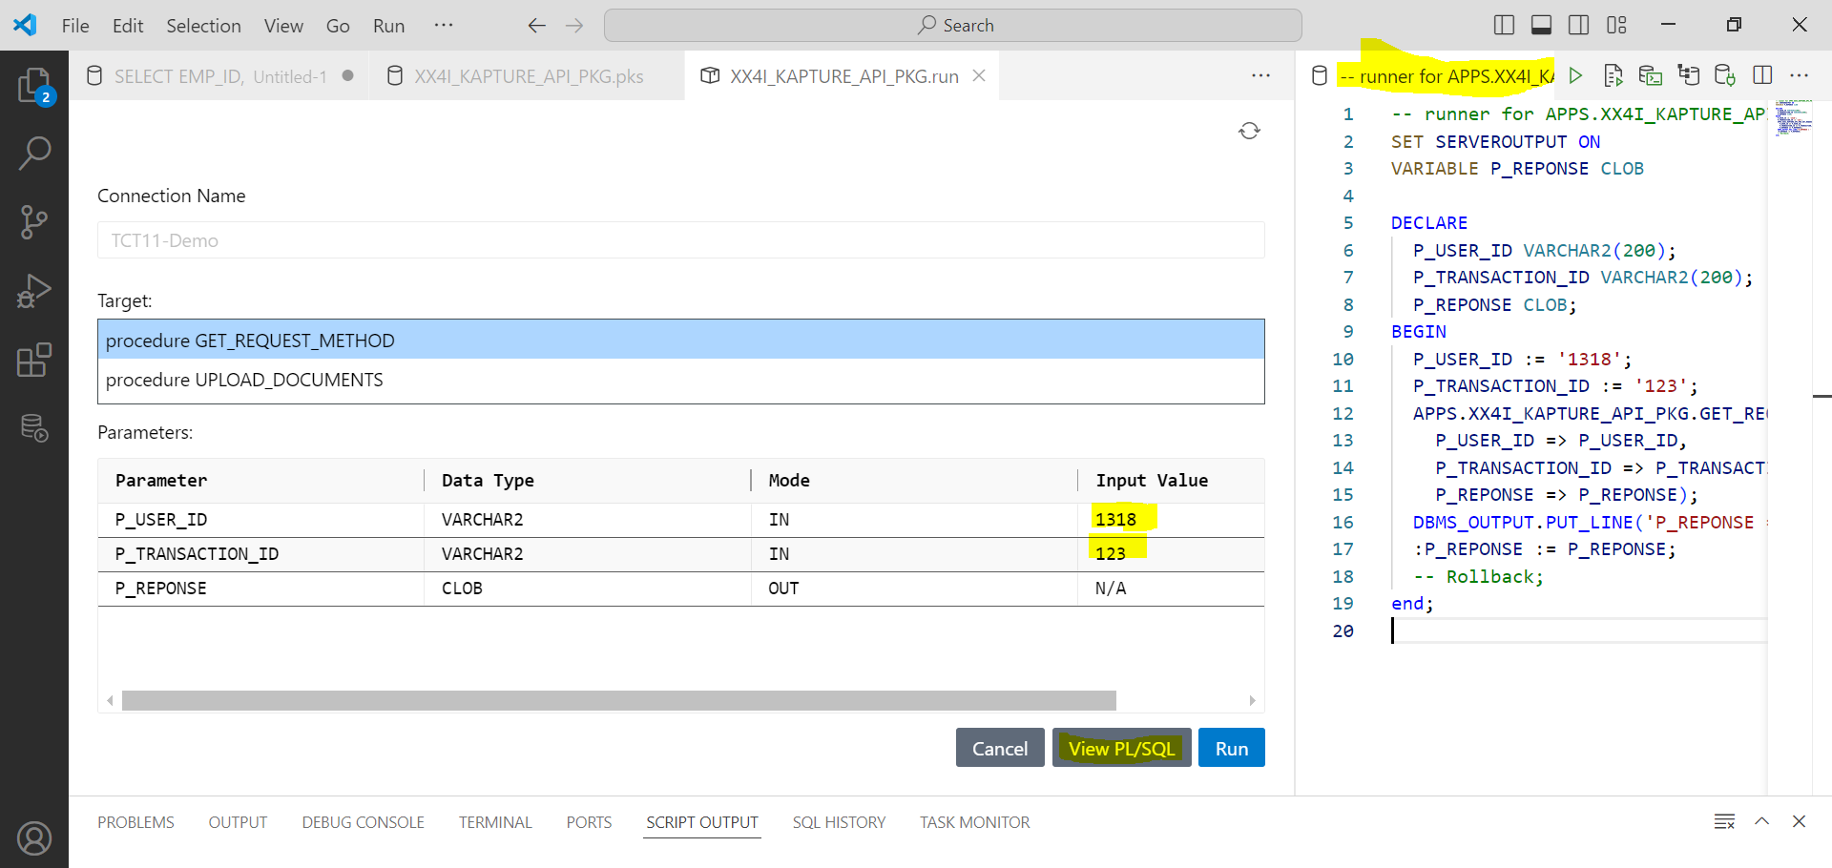

**2.6 Generate CSV, JSON format data.**

* Open the worksheet.

|  |
| --- |
| set sqlformat **csv or json**  select * from po_headers_all; |

* Click on Run script action button.

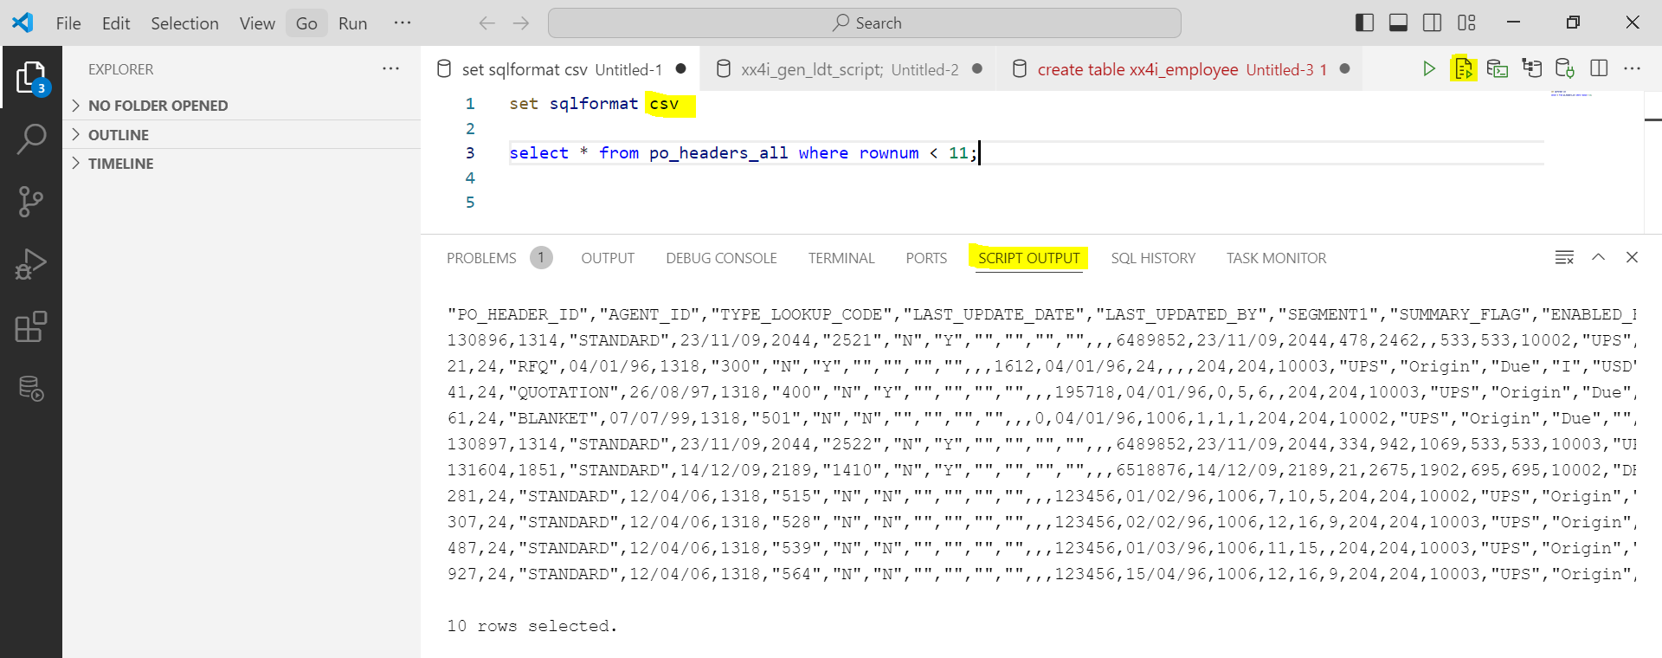

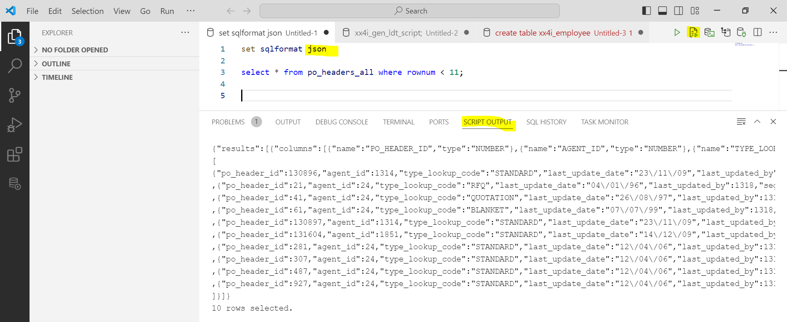

**2.7 Save File and Open File.**

* To save file.
* Go to File 🡪 **Save or Save as**.

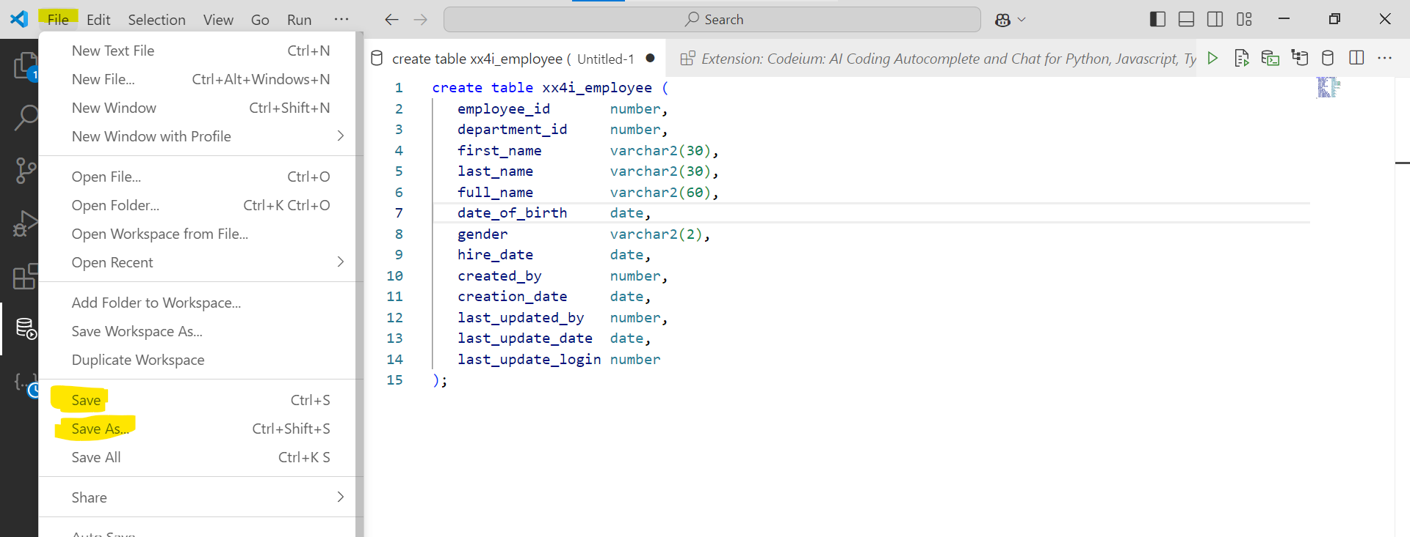

* Save as type MS SQL or PLSQL.

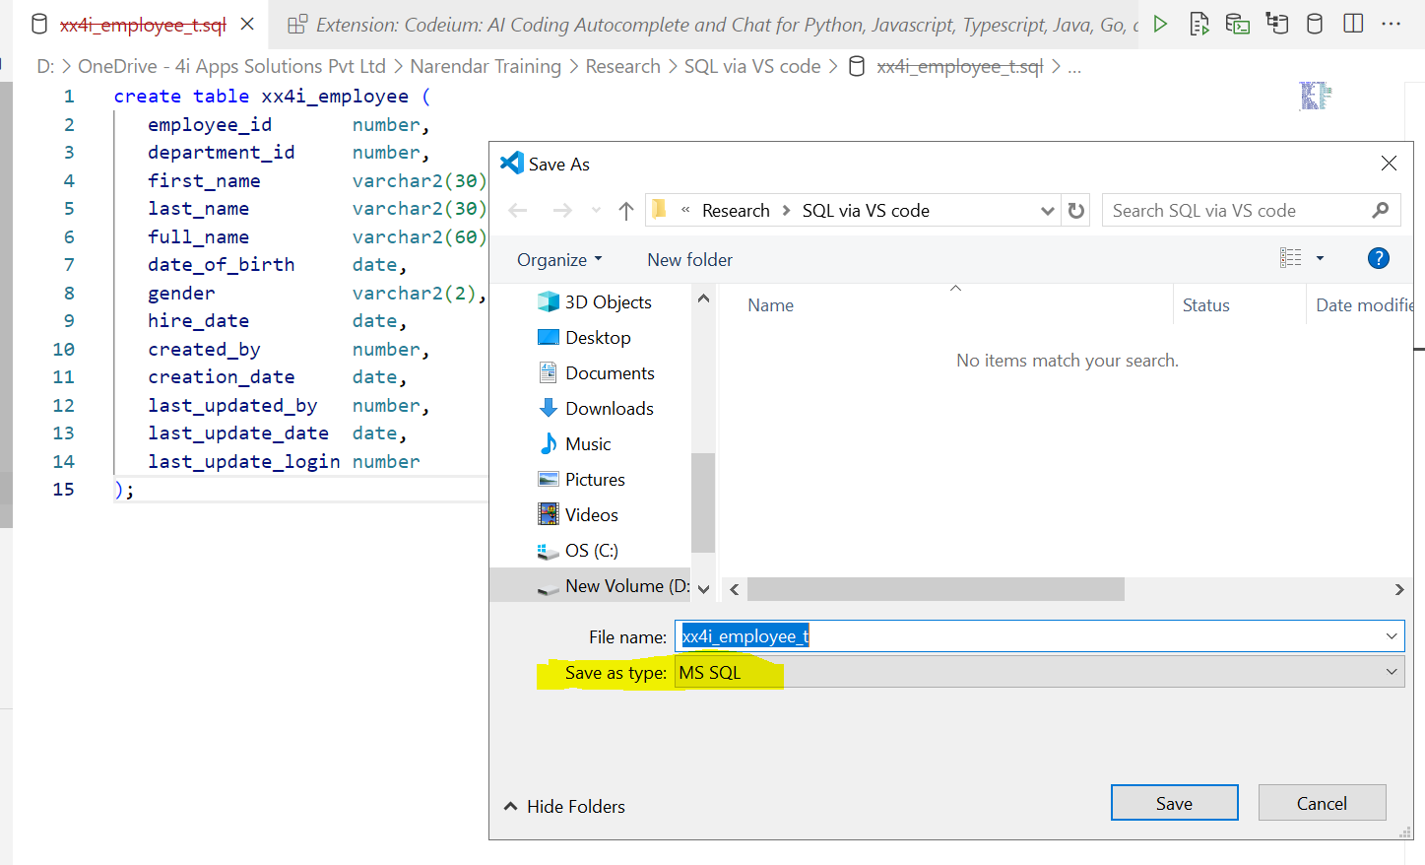

* To open file.
* Go to File 🡪 Open File.

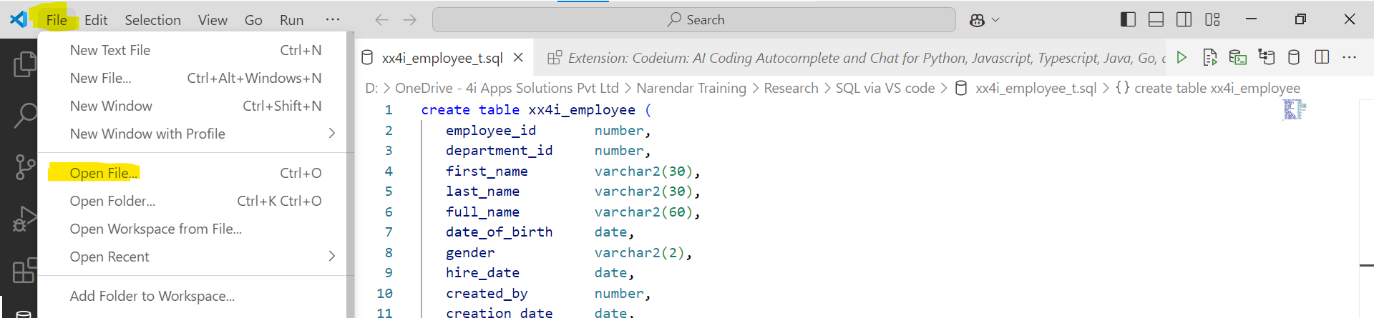

* Browse file and click open.

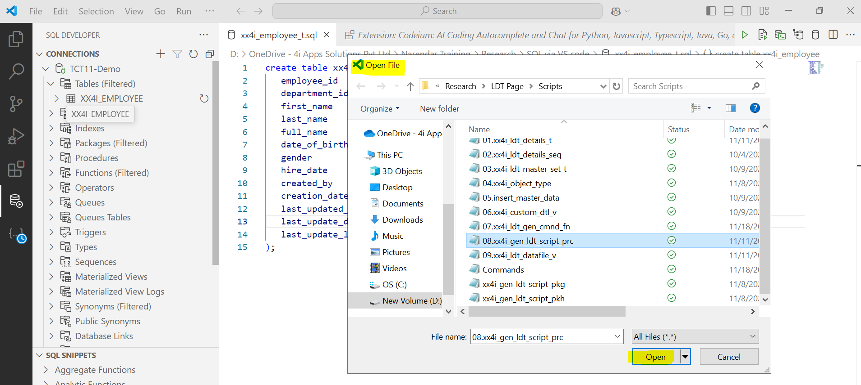

**2.8 Special Features.**

* Locate the table object under the connection.
* Right-click on the object to view options like Columns, Constraints, Indexes, etc.
* You can directly use this feature to perform actions like adding a column or renaming it.

**For example:** Add Column, Rename

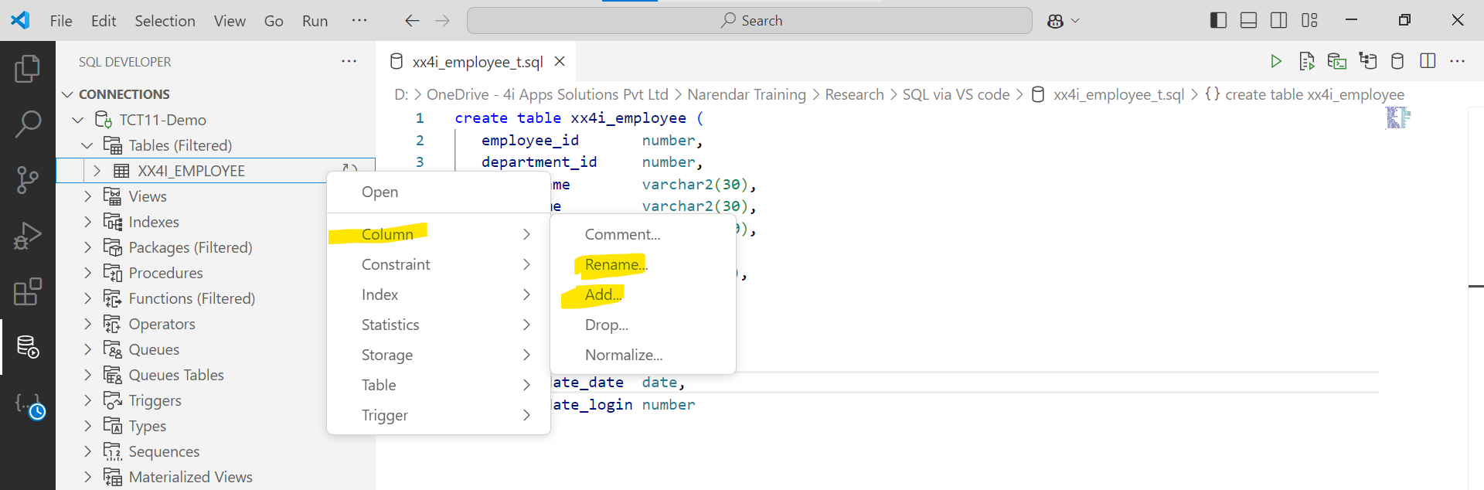

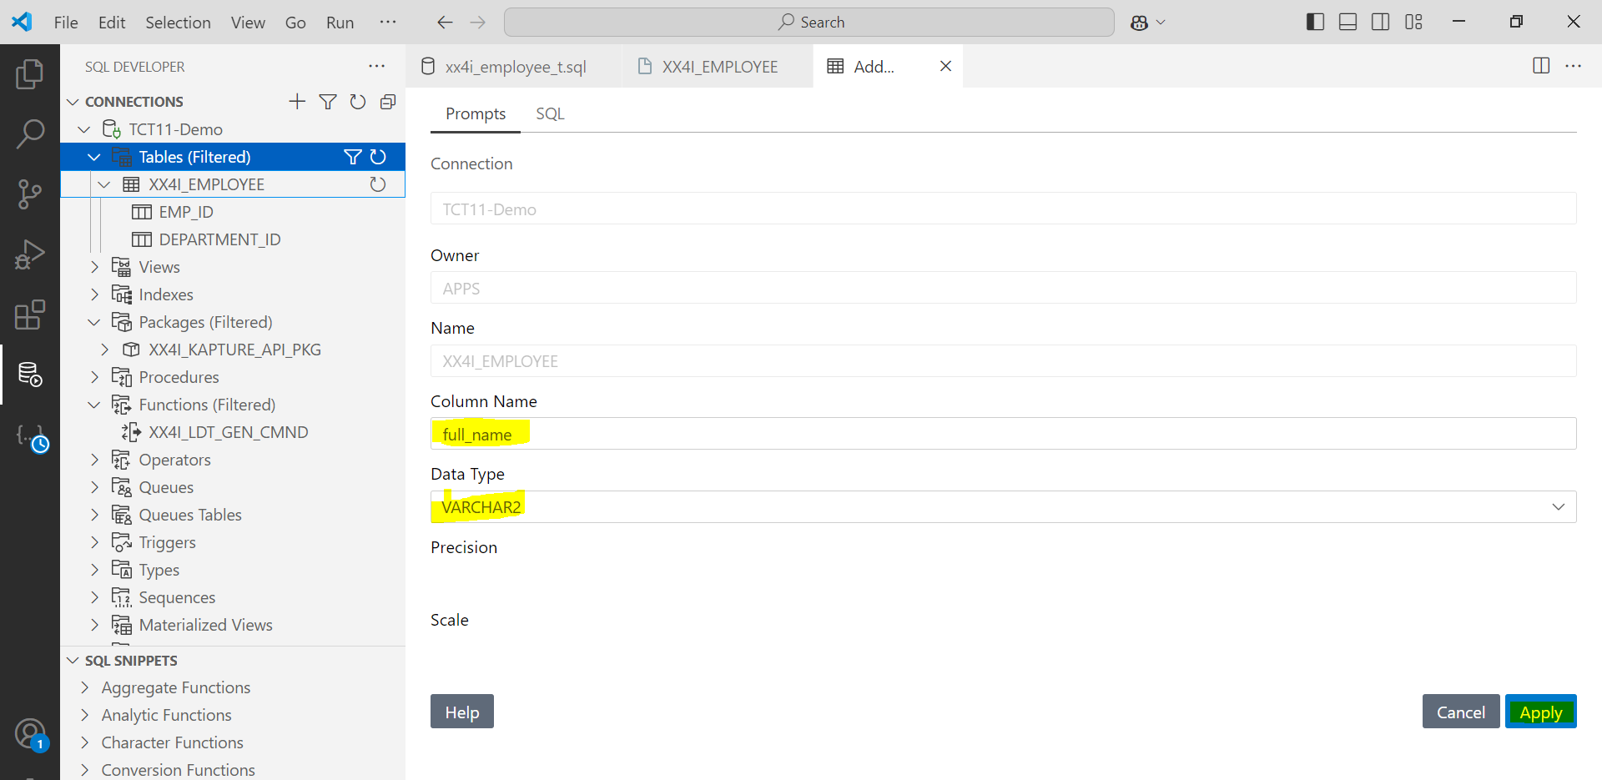

* Fill in the column name, data type, precision, and click **Apply**.

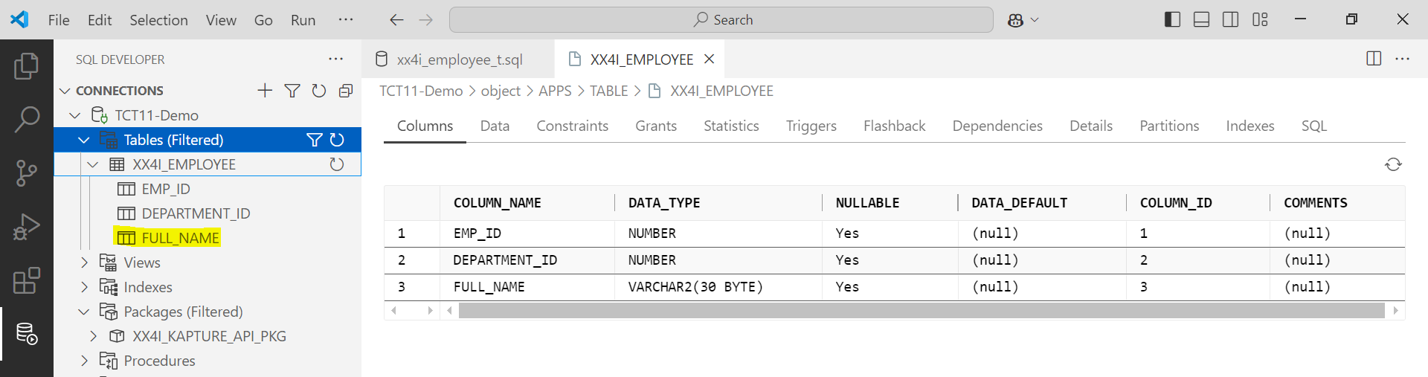

* Right-click on the object and choose the **Rename** option.  
    
  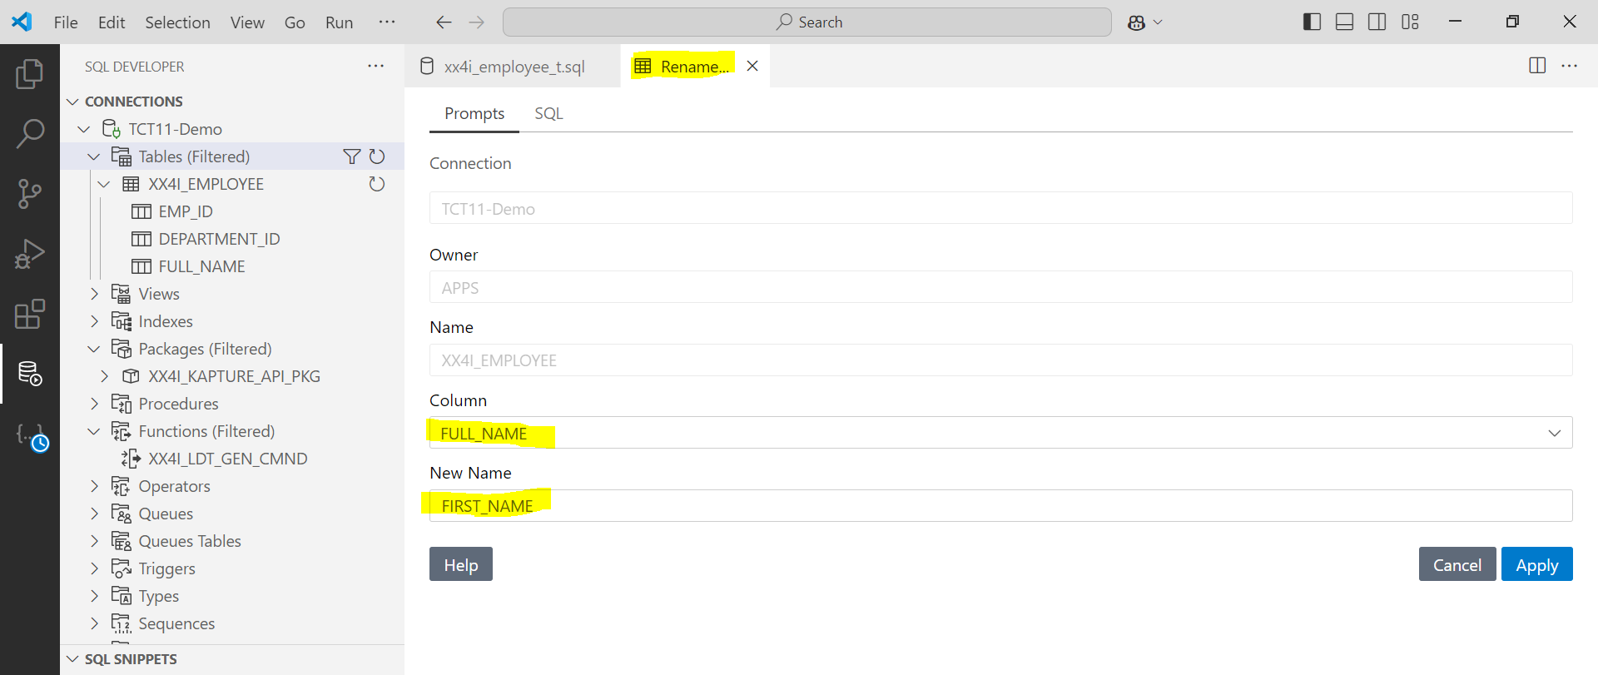

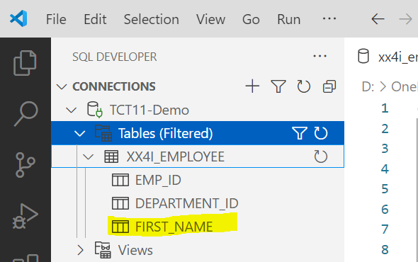

* To add constraints.
* Right-click on the object, select **Constraint**, and choose **Add Primary Key** or **Add Foreign Key**.

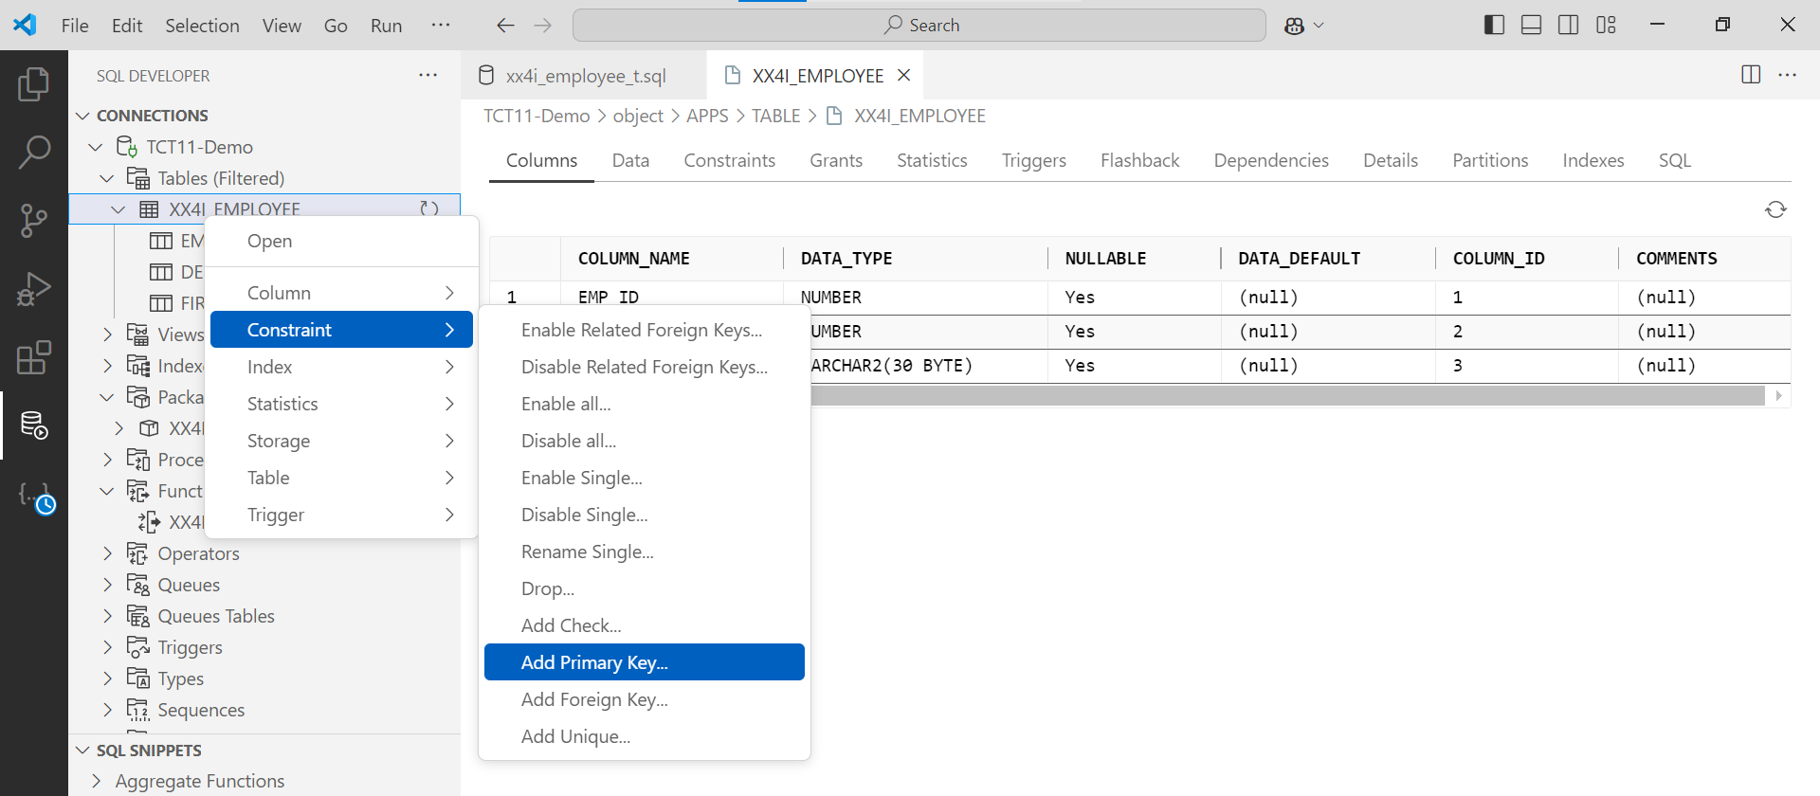

* Fill in the primary key or foreign key name and select the appropriate column(s).  
  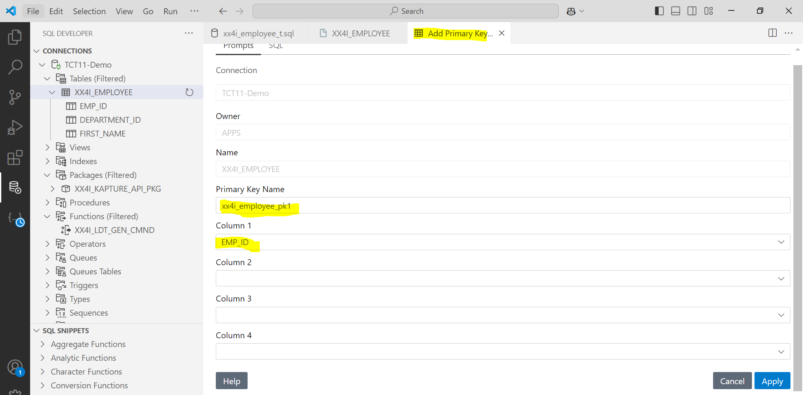
* Click apply.

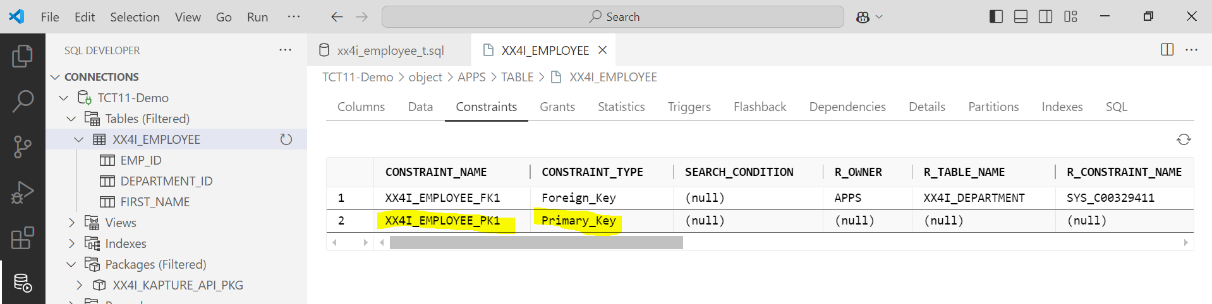

* Similarly, you can perform actions like creating triggers, indexes, or specifying tablespaces.